Introduction:Apple is an American corporation that develops and sells computer electronics, software, personal computers and portable devices internationally. Founders Steve Jobs, Steve Wozniak and Ronald Wayne established Apple in 1976, with its incorporation in 1977. Apple has a history that spans over 30 years, and during that time the company has experienced its ups and downs in financial performance. It was after 2007 when Apple finally achieved widespread success with the launch of the iPhone, the iPod touch and the iPad. It is traded on the NASDAQ under the ticker AAPL . The Organization Today As of August 2012, Apple has 393 retail stores in fourteen countries. Apple is also the third-largest mobile phone maker after Nokia and Samsung. Recently, it introduced a variety of new products such as the iPhone 5, iPad mini, iPad 4 and the All-new iMac. The reported net income of the fourth quarter is about 24% higher than that in the year-ago quarter. Sales of iPhones represent 58% unit growth over the year-ago quarter. However, those high numbers in earnings have not met investors’ expectations. The share price of Apple dropped after the fourth quarter earnings report and also recently following the iPad mini launc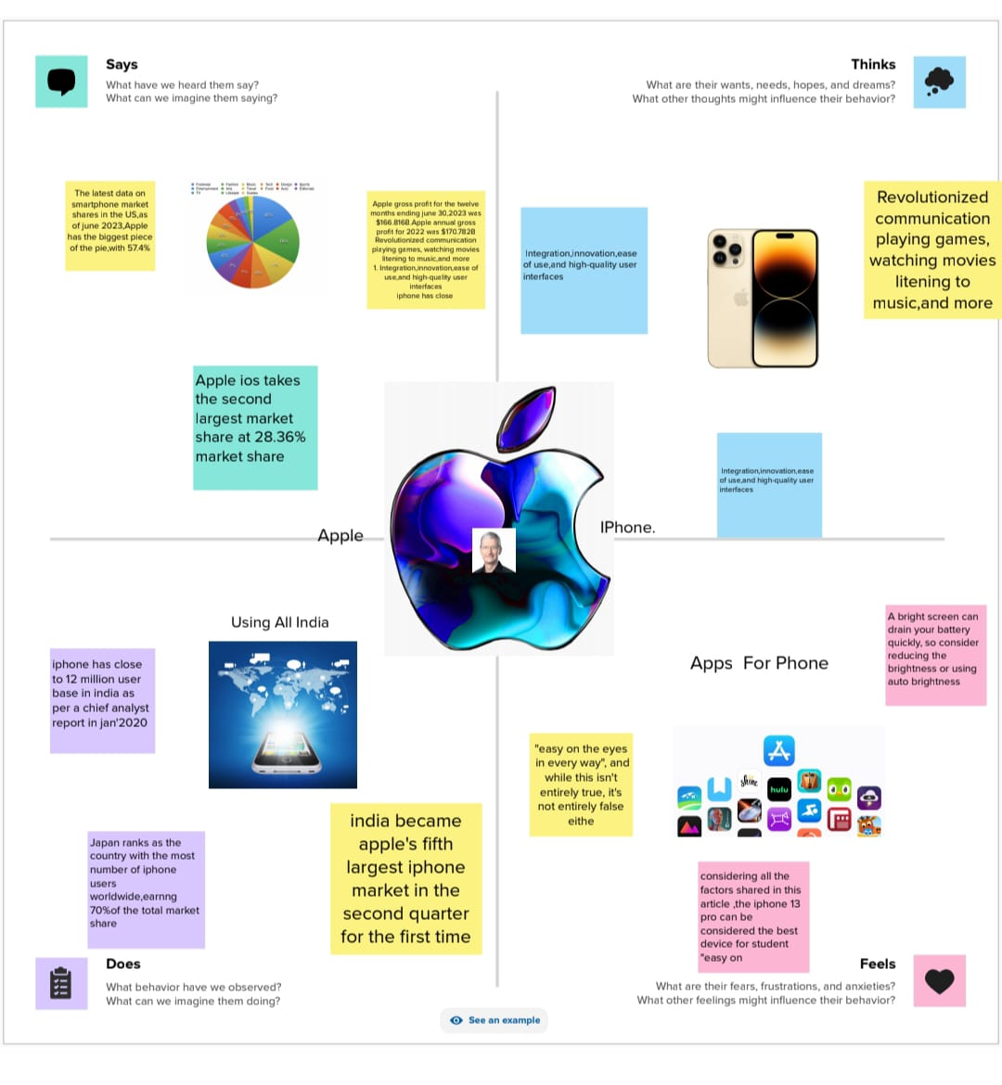h.